Project Management SaaS (PMSaaS)

Documentation

Index

2 Start of the project 4

3 Requirements 4

4 Database 5

5 GUI mock-ups & current design 7

6 Page structure 10

7 Implementation 11

7.1 ch.zhaw.init.walj.projectmanagement 11

7.1.1 Login 11

7.1.2 Logout 11

7.1.3 ResetPassword 11

7.2 ch.zhaw.init.walj.projectmanagement.admin 11

7.2.1 AdminFilter 11

7.2.2 Setup 11

7.3 ch.zhaw.init.walj.projectmanagement.admin.properties 11

7.3.1 AddEmployee 11

7.3.2 AdminProperties 12

7.3.3 ArchiveProject 12

7.3.4 DeleteEmployee 12

7.3.5 DeleteProject 12

7.3.6 EditEmployee 12

7.3.7 RestoreProject 12

7.4 ch.zhaw.init.walj.projectmanagement.errorpages 12

7.4.1 AccessDenied 12

7.4.2 ProjectNotFound 12

7.5 ch.zhaw.init.walj.projectmanagement.user 12

7.5.1 EffortOverview 12

7.5.2 Help 13

7.5.3 Overview 13

7.5.4 Profile 13

7.5.5 ProjectOverview 13

7.6 ch.zhaw.init.walj.projectmanagement.user.add 14

7.6.1 AddEmployee 14

7.6.2 AddExpense 14

7.6.3 AddProject 14

7.6.4 AddTask 14

7.6.5 AddWorkpackage 14

7.6.6 AssignEmployee 14

7.6.7 BookHours 14

7.6.8 ChooseTask 14

7.6.9 ChooseTaskToBookHours 15

7.7 ch.zhaw.init.walj.projectmanagement.user.delete 15

7.7.1 ArchiveProject 15

7.7.2 DeleteEffort 15

7.7.3 DeleteExpense 15

7.7.4 DeleteTask 15

7.7.5 DeleteWorkpackage 15

7.8 ch.zhaw.init.walj.projectmanagement.user.edit 15

7.8.1 Edit 15

7.8.2 EditEffort 15

7.8.3 EditExpense 16

7.8.4 EditProject 16

7.8.5 EditTask 16

7.8.6 EditWeight 16

7.8.7 EditWorkpackage 16

7.9 ch.zhaw.init.walj.projectmanagement.user.share 16

7.9.1 ShareProject 16

7.10 ch.zhaw.init.walj.projectmanagement.util 16

7.10.1 DataBaseAccess 16

7.10.2 DBConnection 17

7.10.3 Effort 19

7.10.4 ExpenseTypes 20

7.10.5 HTMLFooter 20

7.10.6 HTMLHeader 20

7.10.7 LoginFilter 21

7.10.8 Mail 21

7.11 ch.zhaw.init.walj.projectmanagement.util.chart 21

7.11.1 GanttChart 21

7.11.2 LineChart 22

7.11.3 PieChart 22

7.12 ch.zhaw.init.walj.projectmanagement.util.dbclasses 22

7.12.1 Assignment 22

7.12.2 Booking 23

7.12.3 Employee 23

7.12.4 Expense 24

7.12.5 Project 24

7.12.6 Task 25

7.12.7 Weight 27

7.12.8 Workpackage 27

7.13 ch.zhaw.init.walj.projectmanagement.util.format 28

7.13.1 DateFormatter 28

7.13.2 NumberFormatter 28

7.14 ch.zhaw.init.walj.projectmanagement.util.password 29

7.14.1 PasswordGenerator 29

7.14.2 PasswordService 29

# Start of the project

Project Management SaaS, short PMSaaS, is an easy-to-use tool to keep track of your projects. The requirements where discussed with the project leaders of the Service Engineering team in a workshop at the start of the project. The main project was planned from June to October 2016. The presentation at the end of October gave new inputs and ideas for optimizations. Between then and mid of April, these optimizations were implemented. During the IPA (Individuelle Praktische Arbeit) from 19.04.2017 – 03.05.2017 another new function will be implemented.

# Requirements

All requirements that resulted from the workshop with the project leaders are here listed:

1. Project setup
   1. Enter tasks, start, end, PMs
   2. Map task to work package / task account in ZEUS
   3. Add people to the project
2. Monthly effort tracking
   1. Enter who has billed how much on each task
   2. (optional) import hours from CSV 🡪 apply consumed effort to task
3. Planning
   1. Assign people to task (hours)
4. Reporting
   1. Periodic 🡪 effort spent from date to date broken down per month

# Database

The database was designed at the start of the project but a few changes were made during the implementation of PMSaaS. The most significant changes were adding the two tables Weight and Share.

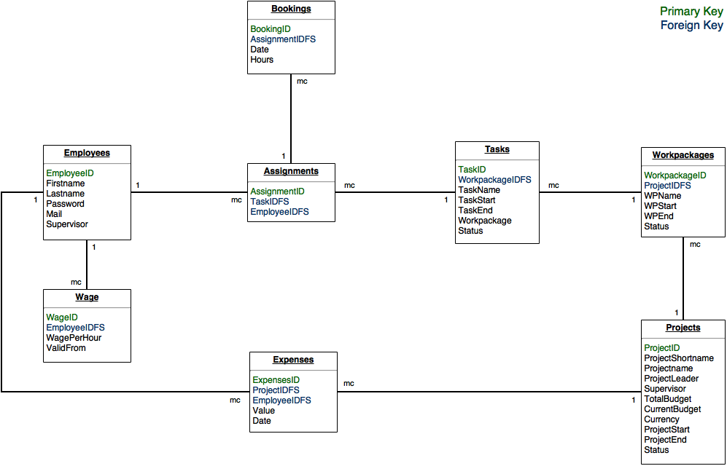

Entity Relationship Model 1, 13.06.2016

C:\Users\Janine\AppData\Local\Microsoft\Windows\INetCache\Content.Word\ERM.PNG

Entity Relationship Model 2, 31.10.2016

C:\Users\Janine\AppData\Local\Microsoft\Windows\INetCache\Content.Word\Projektverwaltung ERM.PNG

Entity Relationship Model 3, 07.11.2016

# GUI mock-ups & current design

In the initial phase of the project, different mock-ups were made. However, the design of PMSaaS changed during the development. Here is a comparison of the mock-ups and the current design.

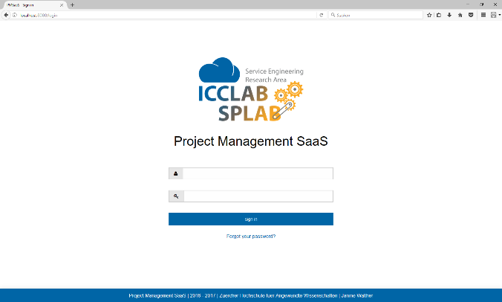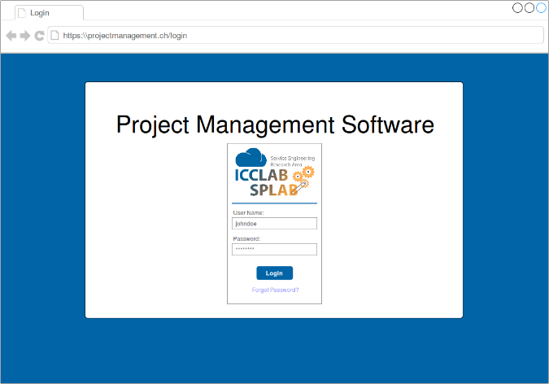

Mock-Up 1 Login

Screenshot 1 Login

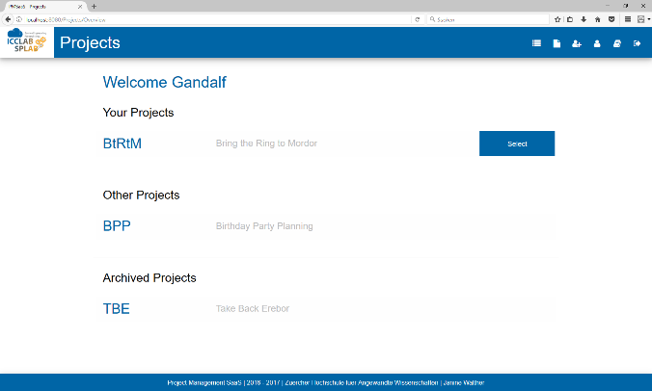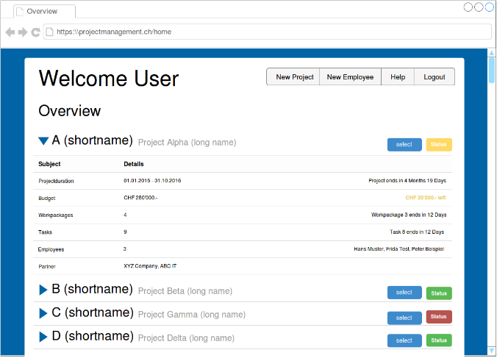

Mock-Up 2 Overview (home screen)

Screenshot 2 Overview (home screen)

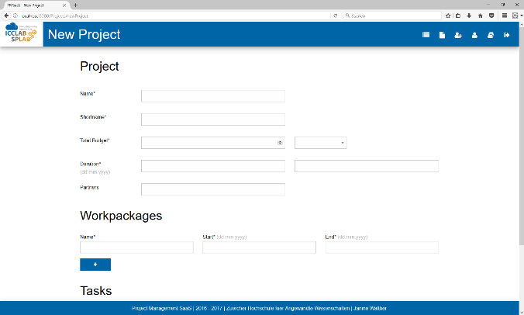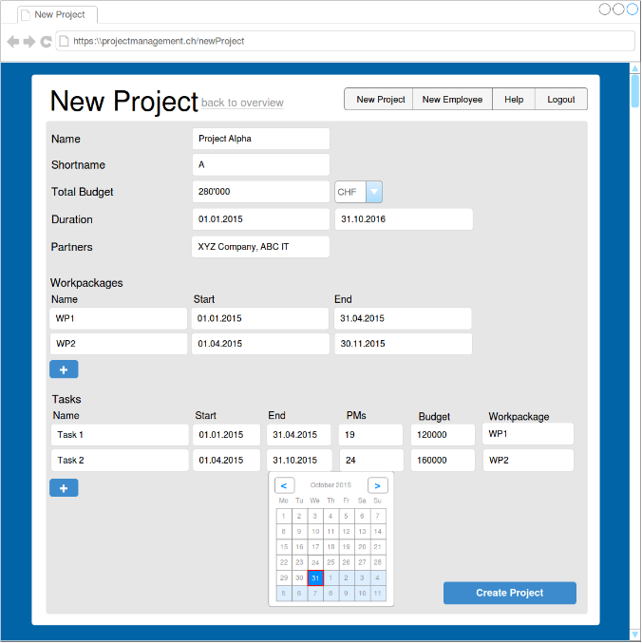

Mock-Up 3 New Project

Screenshot 3 New Project

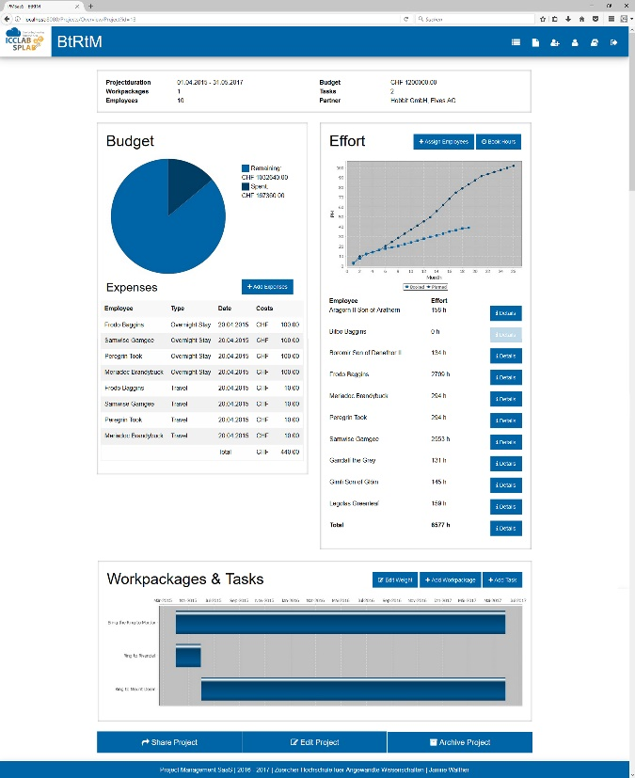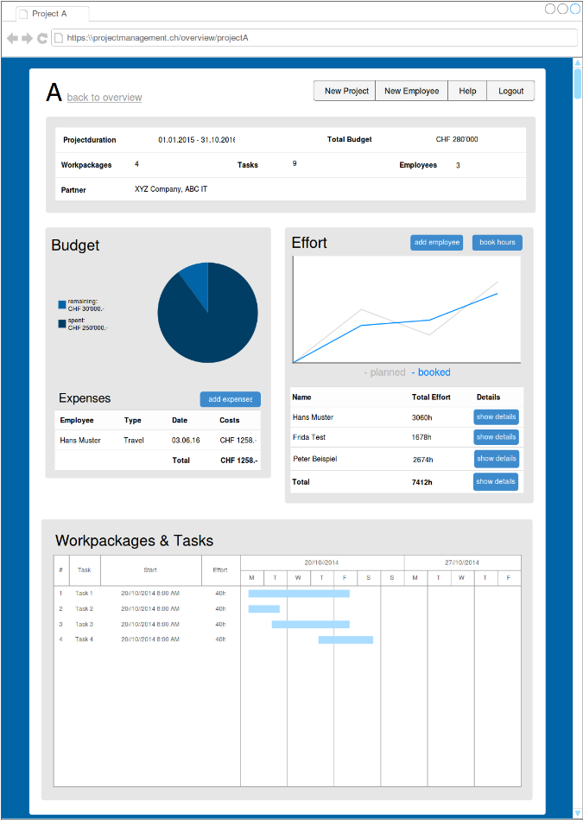

Mock-Up 4 Project Overview

Screenshot 5 Project Overview

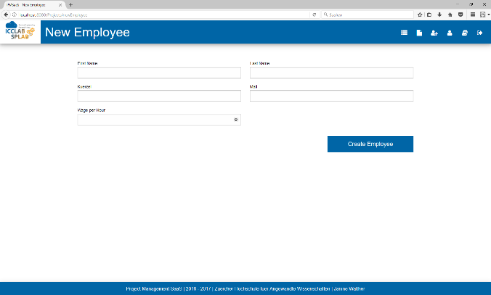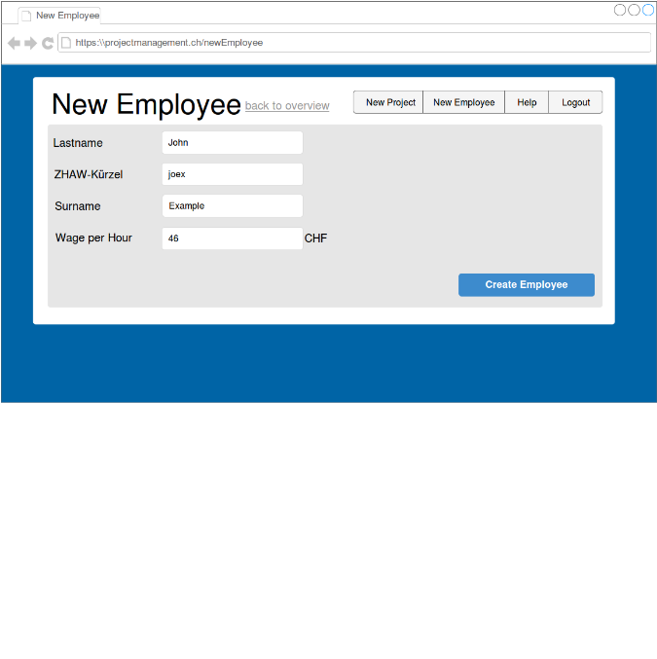

Mock-Up 5 New Employee

Screenshot 4 New Employee

As you can see, there are a few differences between the mock-ups and the current design. On the left top, you can see a logo which can be changed by the admin. The design in the mock-ups was a bit confusing, the new one is clearer. PMSaaS consist of a lot more pages, but there was not for all a mock-up made.

# Page structure

Here is a structure of all pages PMSaaS consists:

Figure 1 Structure PMSaaS

# Implementation

This chapter will describe all classes that are used in PMSaaS ordered by package. All classes, that are not in the package ch.zhaw.init.walj.projectmanagement.util or its sub packages, are servlets that have only a doGet() or/and a doPost() method. Because of this reason, the methods have no own description.

## ch.zhaw.init.walj.projectmanagement

### Login

Page where users and the admin can log in to PMSaaS. Users can login with their kuerzel or e-mail address. The login page compares the entered data with the database and creates a session for the user if the login was correct.

### Logout

If the user or admin clicked on the logout button, he will be forwarded to the logout page. The page destroys the current session and shows a link to go to the login page.

### ResetPassword

ResetPassword creates a new password and sends it to the user as an e-mail. The password will be generated by the class PasswordGenerator and then sent to the user. After this, it will be encrypted and saved in the database.

## ch.zhaw.init.walj.projectmanagement.admin

### AdminFilter

This class is a filter that makes sure that only the admin can access the admin pages. If nobody is logged in it will redirect to the Login page. If another user, who is not the admin, is logged in, it redirects to the AccessDenied page.

### Setup

The Setup page will be shown when there is no database found by PMSaaS. I this case, the user must declare where the server with MySQL running on it is located (URL + port), how the database should be named and what the login credentials are. In addition to that, the mail server must be declared and from what e-mail address users should get notifications. Last step is to enter the admin’s e-mail address and choose a password. The class setup will then create the database with all its tables, write all information in a config file and create the admin user. The admin will receive an e-mail to confirm that PMSaaS was successfully installed and can be used now.

## ch.zhaw.init.walj.projectmanagement.admin.properties

### AddEmployee

The user can add an employee here. After entering all information, the page will create a new user in the database with a generated and encrypted password. The new user will receive an e-mail with the entered data and his password. If everything was successful, the page will return a message with the data of the employee.

### AdminProperties

This is the first page the admin will see after the login page. Here he can change the logo and see all employees and projects in a list. The admin can choose an employee and edit or delete it. Projects can be edited, deleted, or archived / restored.

#### Change Logo

If the admin likes to change the logo he must upload 2 PNG files. One for the larger logo that is used on the start, login and logout page. The smaller one is used on all other pages. It is implemented like this so the admin can use 2 different versions of the logo.

### ArchiveProject

Every project has an archive flag in the database. The ArchiveProject page changes this flag from 0 (not archived) to 1 (archived). The site will show a success or error message.

### DeleteEmployee

The admin can delete employees if they don’t have any projects or expenses or are assigned to some tasks. The admin will get a notification if the employee could not be deleted with a list of all reasons. If deleting the employee was successful, a message will inform the admin.

### DeleteProject

Only the admin has the permission to delete projects. If a project is deleted, there is no possibility to restore it. The project will be deleted with all its work packages, tasks, expenses and assignments. A success or error message will be shown to the user.

### EditEmployee

Employees can be edited by the admin. A form will be shown where he can edit name, kuerzel, e-mail and wage per hour. If the employee was successfully updated, a message with all new information will be shown, if an error occurred, PMSaaS shows an error message.

### RestoreProject

The admin can restore archived projects. The RestoreProject page will restore an archived project and show an error or success message, depending on the project could be restored or not.

## ch.zhaw.init.walj.projectmanagement.errorpages

### AccessDenied

The AccessDenied page will be shown to a user who tried to access a page without the needed permission. It simply shows a message that the user is not allowed to visit the requested site.

### ProjectNotFound

This site shows an error if someone tried to reach a project that does not exist (anymore).

## ch.zhaw.init.walj.projectmanagement.user

### EffortOverview

The EffortOverview site will give its user an overview about the effort in a project. This overview can be with all assigned employees included or with only one of them. If there is a get parameter employeeID, the page will only show the effort of this employee. A LineChart will visualize the hours of effort for the specific employee in each month. If there is no employee specified, the line chart will compare the planned (PMs) and booked effort.

### Help

This page is for assisting the user in using PMSaaS. It’s a helpful description with all essential functions of the tool.

### Overview

The overview page is the first page a user sees. There are 3 lists: own projects, projects other people shared with me and own projects that I had archived. The lists are made with foundation accordion (look here for more information about that <http://foundation.zurb.com/sites/docs/kitchen-sink.html#accordion>). Overview will get all needed projects from the database and arrange them in the list. Every own project has a button to get to its ProjectOverview.

### Profile

Profile creates a form with the user’s data like name, kuerzel and e-mail. Further, the user can change his password here. The class Profile will update the information in the database and shows an error or success message.

### ProjectOverview

The ProjectOverview class provides most of the usability of PMSaaS. It shows for ever project 4 panels:

* a short statistic with duration of the project, total budget, number of work packages, tasks and employees and the names of all partners
* a budget panel with a PieChart that compares the spent and remaining budget and a list of all expenses
* an effort panel with a LineChart that compares planned and booked effort and a list with all employees and the amount of their booked hours
* a panel with a Gantt chart that shows all work packages and tasks

Below these panels are three buttons to share, edit or archive the project.   
While the first panel has no possibility of interaction, the others implement many different functions.

* Budget
  + AddExpense
* Effort
  + AssignEmployee
  + BookHours
  + Details employee (EffortOverview)
  + Details project (EffortOverview)
* Workpackages & Tasks
  + EditWeight
  + AddWorkpackage
  + AddTask

The ProjectOverview class gets all data from the database, creates the charts and fills the data into these panels.

## ch.zhaw.init.walj.projectmanagement.user.add

### AddEmployee

Every user can add new employees if the kuerzel and e-mail are not used yet. After fill in the information, the class will call the PasswordGenerator to generate a new password and send an e-mail with all data (including the password) to the new user.

### AddExpense

The AddExpense class creates a form to record expenses. The expense types are defined in a separate Enum class. AddExpense gets all options from ExpenseTypes and writes them into a select field. The currency of the costs field is defined by the currency of the project. The expense will be added to the database.

### AddProject

AddProject can create a new project with work packages and tasks in the database. The form consists of 3 parts:

1. Project information (name, duration, budget, etc.)
2. Workpackages
3. Tasks

The parts work packages and tasks each have a button to add more fields. Every click on one of these buttons calls a JavaScript function that adds a new group of fields under the existing ones.   
An instance of DateFormatter controls if all dates are possible (start date before end date, etc.). If everything was ok, the project and its work packages and tasks will be added to the database.

### AddTask

If needed, the project leader can add new tasks to his projects. This is nearly the same function as in AddProject. An instance of DateFormatter controls if all dates are possible (start date before end date, etc.). If everything was ok, the task will be added to the database.

### AddWorkpackage

If needed, the project leader can add new work packages to his projects. This is nearly the same function as in AddProject. An instance of DateFormatter controls if all dates are possible (start date before end date, etc.). If everything was ok, the work package will be added to the database.

### AssignEmployee

To book hours, an employee must be assigned. On the AssignEmployee page the user must choose an employee out of a list with all employees. With a click on the Choose Task button, the page ChooseTask will be opened. After choosing the task the user will be redirected back to AssignEmployee where the new assignment will be added to the database.

### BookHours

BookHours lets the user choose from a list of employees, like in AssignEmployee. After choosing the employee it will redirect to ChooseTaskToBookHours where you can choose for which tasks you want to book hours. After fill in all hours it will redirect back to BookHours where the bookings will be written into the database.

### ChooseTask

This page will be called from AssignEmployee to choose the task where the employee should be assigned to. It creates a list with all tasks of the project, to whom the employee is not assigned yet. The user can choose more than one task, as multiple options are allowed. After choosing the task, ChooseTask will redirect back to AssignEmployee.

### ChooseTaskToBookHours

After choosing the employee in BookHours, ChooseTaskToBookHours will be called. Like in ChooseTask, the user will see a list where he can choose the task where he wants to book hours. He can choose more than one task, as multiple options are allowed. A form will be created where the user can book hours for every task he chose. When all hours are filled in, the data will be sent to BookHours, where it will be written into the database.

## ch.zhaw.init.walj.projectmanagement.user.delete

### ArchiveProject

For better finding the current projects, users can archive completed projects. ArchiveProject will change the flag in the database from 0 (not archived) to 1 (archived).

### DeleteEffort

DeleteEffort will delete the chosen booking in the database and write a success or error message in the browser.

### DeleteExpense

The chosen expense will be deleted from the database and a success or error message will be shown.

### DeleteTask

Users can delete tasks after being warned that with the task, all bookings and assignments will be deleted too. DeleteTask will delete the chosen task and print a success or error message.

### DeleteWorkpackage

Like in DeleteTask, the user will be warned that all tasks and bookings of a work package will be deleted too. The chosen work package will then be deleted and a success or error message will be shown to the user.

## ch.zhaw.init.walj.projectmanagement.user.edit

### Edit

The edit page is the starting point for editing and deleting various parts of the project. Edit consists of the following parts:

* Project
* Workpackages
* Tasks
* Expenses
* Effort

If you edit one of the entries, Edit will send the edited data to another page that will update the database.

### EditEffort

Updates the effort with the given data in the database and returns a success or error message.

### EditExpense

Updates the expense with the given data in the database and returns a success or error message.

### EditProject

Updates the project with the given data in the database and returns a success or error message.

### EditTask

Updates the task with the given data in the database and returns a success or error message.

### EditWeight

Creates new entries or updates existing ones in the weight table of the database.

### EditWorkpackage

Updates the work package with the given data in the database and returns a success or error message.

## ch.zhaw.init.walj.projectmanagement.user.share

### ShareProject

ShareProject will first create a list with all employees, with whom the project is not shared yet. The user can then decide with which of the listed employees he likes to share his project. He can choose more than one, as multiple options are allowed. For the chosen employees will be an entry in the share table of the database created. They will see the project now in their overview under “Other Projects”.

## ch.zhaw.init.walj.projectmanagement.util

### DataBaseAccess

|  |  |  |  |
| --- | --- | --- | --- |
| Name | Type | Description | public/private |
| url | String | the url of the MySQL database | private |
| dbname | String | the name of the MySQL database | private |
| username | String | name of the user of the MySQL database | private |
| password | String | password of the MySQL user | private |

Table 1 Variables DataBaseAccess

|  |  |  |  |
| --- | --- | --- | --- |
| Name | Description | public /  private | return |
| DataBaseAccess(String path) | Constructor, reads .config file and initializes the variables url, dbname, username and password | public | - |
| getUrl() | returns the content of url | public | url |
| getDbname() | returns the content of dbname | public | dbname |
| getUsername() | returns the content of username | public | username |
| getPassword() | returns the content of password | public | password |

Table 2 Methods DataBaseAccess

### DBConnection

|  |  |  |  |
| --- | --- | --- | --- |
| Name | Type | Description | public/private |
| conn | Connection | Connection to the database | private |
| st | PreparedStatement | Statement for MySQL queries | private |
| res | ResultSet | variable to save the result of a query | private |
| noConnection | boolean | true if DBConnection could no connect to Database | private |

Table 3 Variables DBConnection

|  |  |  |  |
| --- | --- | --- | --- |
| Name | Description | public /  private | return |
| DBConnection(String path) | Constructor, creates a connection to the database and initializes noConnection | public | - |
| getProject(int pID) | gets the project with the given ID from the Database and creates a new Project object | public | Project object |
| getProjects(int id, boolean archive) | creates a list with all projects where the given user is project leader. If archive is true, only archived projects, else only not archived projects will be in the list | public | list of projects |
| getWorkpackages(int id) | creates a result set with all work packages of the project | private | result set with all work packages |
| getTasks(int id) | creates a result set with all tasks of the project | private | result set with all tasks |
| getEmployee(int id) | creates an employee object from the employee with the given ID | public | Employee object |
| getSharedEmployees(int projectID) | creates a list with all employees with whom the project is shared | public | list of employees |
| getSharedProjects(int id) | get all projects that are shared with the given employee | public | list of projects |
| getAllEmployees() | creates a list with all employees (without administrator) | public | list of employees |
| getAssignedTasks(int employee) | get all tasks the given employee is assigned to | public | list of task IDs |
| getAssignments(int taskID) | get all assignments to the given task | public | list of assignments |
| getAssignment(int employeeID, int taskID) | get the assignment with the given employee and task | public | assignment object |
| getExpenses(int id) | list with the IDs of all expenses of the given employee | public | list of expense IDs |
| getBookings (Assignment assignment) | get all bookings to a specific assignment | public | list of bookings |
| getUsedBudget(Project project) | calculates the used budget of a project | public | used budget |
| getRemainingBudget(Project project) | calculates the remaining budget of a project | public | remaining budget |
| findUser(String user, String password) | tries to find a user in the database | public | employee object or null |
| findUser(String user) | tries to find a user in the database | public | employee object or null |
| newProject(String pName, String pShortname, int pLeader, String pBudget, String pCurrency, String pStart, String pEnd, String pPartners) | creates a new project in the database | public | ID of the new project |
| newWorkpackage(int projectIDFS, String wpName, String wpStart, String wpEnd) | creates a new work package in the database | public | - |
| newTask(int projectID, String wpName, String taskName, String taskStart, String taskEnd, String taskPM, String taskBudget) | creates a new task in the database | public | - |
| newTask(int wpID, String taskName, String taskStart, String taskEnd, String taskPM, String taskBudget) | creates a new task in the database | public | - |
| newEmployee(int employeeID, String firstname, String lastname, String kuerzel, String mail, int wage) | creates a new employee and wage in the database, password will be generated | public | employee object |
| newEmployee(int employeeID, String firstname, String lastname, String kuerzel, String mail, String password, int wage) | creates a new employee and wage in the database, password is known | public | employee object |
| newExpense(int projectID, int employeeID, double costs, String type, String description, String date) | creates new expense in the database | public | - |
| newAssignment(int taskID, int employeeID) | creates new assignment in the database | public | - |
| newBooking(int assignment, int month, double hours) | creates new booking in the database | public | - |
| newWage(int userID, double wage, String date) | creates new wage in the database | public | - |
| newWeight(int taskID, int month, double weight) | creates new weight in the database | public | - |
| newShare(int projectID, int employeeID) | creates new share in the database | public | - |
| updateProject(int id, String name, String shortname, double budget, String currency, String start, String end, String partners) | updates the project with the given data | public | - |
| updateWorkpackage(int id, String name, String start, String end) | updates the work package with the given data | public | - |
| updateTask(int id, String name, String start, String end, int pm, double budget, int wp) | updates the task with the given data | public | - |
| updateExpense(int id, int employee, double costs, String type, String description, String date) | updates the expense with the given data | public | - |
| updateEffort(int id, String month, String hours) | updates the effort with the given data | public | - |
| updateUser(int userID, String firstname, String lastname, String kuerzel, String mail) | updates the user with the given data | public | - |
| updatePassword(int userID, String password) | updates the password of the user | public | - |
| updateWeight(int taskID, int month, double weight) | updates a weight of a task and month | public | - |
| archiveProject(int projectID) | sets the archive flag of a project to 0 | public | - |
| restoreProject(int projectID) | sets the archive flag of a project to 1 | public | - |
| deleteWorkpackage(int workpackageID) | deletes a work package (and all its tasks, assignments and bookings) | public | - |
| deleteTask(int taskID) | deletes a task (and all its assignments and bookings) | public | - |
| deleteExpense(int expenseID) | deletes an expense | public | - |
| deleteEffort(int effortID) | deletes an effort entry | public | - |
| deleteEmployee(int id) | deletes an employee | public | - |
| deleteProject(int projectID) | deletes a project with all its work packages, tasks, assignments, bookings, expenses and shares | public | - |

Table 4 Methods DBConnection

### Effort

|  |  |  |  |
| --- | --- | --- | --- |
| Name | Type | Description | public/private |
| tasks | ArrayList<Task> | ArrayList that can be filled with tasks | private |
| con | DBConnection | Connection to MySQL database | private final |

Table 5 Variables Effort

|  |  |  |  |
| --- | --- | --- | --- |
| Name | Description | public /  private | return |
| Effort (ArrayList<Task> tasks, String path) | Constructor, initializes tasks and creates a connection to the database | public | - |
| getBookings () | creates an ArrayList with all assignments to the tasks and then creates an ArrayList with all bookings to the assignments | public | ArrayList of bookings |
| getBookings (int employeeID) | creates an ArrayList with all bookings of a specific employee in these tasks | public | ArrayList of Bookings |
| getPlannedEffort (double month) | calculates the planned effort for the given month | public | planned effort |
| getBookedEffort (double month) | get the booked effort for a specific month from all tasks | public | booked effort |
| getEffortPerEmployee(int employee) | get the effort of a specific employee in this project | public | effort in hours |
| getBookedEffortPerMonth(double month, int employee) | get the booked effort of a specific employee within the given month | public | effort in hours |

Table 6 Methods Effort

### ExpenseTypes

ExpenseTypes is an Enum which contains all possible expense types of PMSaaS.

|  |  |
| --- | --- |
| Variable | Output |
| TRAVEL | Travel |
| OVERNIGHT_STAY | Overnight Stay |
| MEALS | Meals |
| OFFICE_SUPPLIES | Office Supplies |
| EVENTS | Events |

Table 7 Variables ExpenseTypes

### HTMLFooter

|  |  |  |  |
| --- | --- | --- | --- |
| Name | Type | Description | public/private |
| instance | HTMLFooter | an instance of the HTMLFooter | private static |

Table 8 Variables HTMLFooter

|  |  |  |  |
| --- | --- | --- | --- |
| Name | Description | public /  private | return |
| printFooter(boolean linkToTop) | creates the footer as a string, if linkToTop is true with a link to go to the top of the page | public | String of the footer |
| getInstance() | if instance is not initialized yet, getInstance() initializes it and returns the instance | public static | instance of HTMLFooter |

Table 9 Methods HTMLFooter

### HTMLHeader

|  |  |  |  |
| --- | --- | --- | --- |
| Name | Type | Description | public/private |
| instance | HTMLHeader | an instance of the HTMLHeader | private static |

Table 10 Variales HTMLHeader

|  |  |  |  |
| --- | --- | --- | --- |
| Name | Description | public /  private | return |
| printHeader(…) | creates the header as a string, following attributes are possible: | public | String of the footer |
| String tabTitle, String path |
| String tabTitle, String path, String title, String script |
| String tabTitle, String path, String script |
| String tabTitle, String path, String title, String script, String link, boolean admin |
| String tabTitle, String path, String title, String script, String link, boolean admin, boolean logout |
| getInstance() | if instance is not initialized yet, getInstance() initializes it and returns the instance | public static | instance of HTMLFooter |

Table 11 Methods HTMLHeader

### LoginFilter

LoginFilter is an implementation of the Java Servlet Filter class. It checks at every page call if the user is logged in. If not it redirects to the Login page. The LoginFilter also checks if the user is an administrator or a normal user and redirects to the right page.

### Mail

|  |  |  |  |
| --- | --- | --- | --- |
| Name | Type | Description | public/private |
| mailFrom | String | address that will be shown as the sender of the e-mail | private static |
| host | String | URL of the mail server | private static |
| message | MimeMessage | the mail that will be sent | private |
| user | Employee | the recipient | private |

Table 12 Variables Mail

|  |  |  |  |
| --- | --- | --- | --- |
| Name | Description | public /  private | return |
| Mail (Employee user, String path) | constructor, reads mailconfig and initializes the variables | public | - |
| sendWelcomeMail() | sends a welcome mail to a new user with its data | public | - |
| sendNewPassword() | sends a mail with a newly generated password | public | - |
| sendInitialSetupMail() | sends a mail to the admin as a confirmation that PMSaaS was successfully initialized | public | - |

Table 13 Methods Mail

## ch.zhaw.init.walj.projectmanagement.util.chart

### GanttChart

|  |  |  |  |
| --- | --- | --- | --- |
| Name | Type | Description | public/private |
| project | Project | the project of which a GanttChart should be created | private final |
| workpackages | ArrayList<Workpackage> | list of workpackages | private final |
| tasks | ArrayList<Task> | list of tasks | private final |
| path | String | location of PMSaaS | private final |
| nbrOfObjects | int | needed to calculate height of GanttChart, number of work packages and tasks that are added in the dataset | private |

Table 14 Variables GanttChart

|  |  |  |  |
| --- | --- | --- | --- |
| Name | Description | public /  private | return |
| GanttChart(Project project, String path) | constructor, initializes the variables | public | - |
| createDataset() | creates dataset with all workpackages and tasks of the project | private | dataset |
| createChart() | creates a Gantt chart with the data from the dataset and saves it as a JPEG file | public | - |

Table 15 Methods GanttChart

### LineChart

|  |  |  |  |
| --- | --- | --- | --- |
| Name | Type | Description | public/private |
| project | Project | the project of which a LineChart should be created | private final |
| path | String | location of PMSaaS | private final |
| tasks | ArrayList<Task> | list of tasks | private |

Table 16 Variables LineChart

|  |  |  |  |
| --- | --- | --- | --- |
| Name | Description | public /  private | return |
| LineChart(Project project, String path) | constructor, initializes the variables | public | - |
| createDataset() | creates dataset with the booked and planned effort of the project | private | dataset |
| createDataset(int employeeID) | creates dataset with the booked effort of the given employee | private | dataset |
| createChart() | creates a line chart with the data from the dataset and saves it as a JPEG file | public | - |
| createChart(int employeeID) | creates a line chart with the data from the dataset and saves it as a JPEG file | public | - |

Table 17 Methods LineChart

### PieChart

|  |  |  |  |
| --- | --- | --- | --- |
| Name | Type | Description | public/private |
| project | Project | the project of which a PieChart should be created | private final |
| con | DBConnection | connection to the database | private final |
| path | String | location of PMSaaS | private final |

Table 188 Variables PieChart

|  |  |  |  |
| --- | --- | --- | --- |
| Name | Description | public /  private | return |
| PieChart(Project project, String path) | constructor, initializes the variables | public | - |
| createChart() | creates a pie chart with the spent and remaining budget and saves it as a JPEG file | public | - |

Table 199 Methods PieChart

## ch.zhaw.init.walj.projectmanagement.util.dbclasses

### Assignment

|  |  |  |  |
| --- | --- | --- | --- |
| Name | Type | Description | public/private |
| id | int | the ID of the assignment | private final |
| taskID | int | the ID of the task where the assignment belongs to | private final |
| employeeID | int | the ID of the employee who is assigned to the task | private final |

Table 20 Variables Assignment

|  |  |  |  |
| --- | --- | --- | --- |
| Name | Description | public /  private | return |
| Assignment(int id, int taskID, int employeeID) | constructor, initializes the variables | public | - |
| getID() | returns id | public | id |
| getTaskID() | returns taskID | public | taskID |
| getEmployeeID() | returns employeeID | public | employeeID |

Table 21 Methods Assignment

### Booking

|  |  |  |  |
| --- | --- | --- | --- |
| Name | Type | Description | public/private |
| bookingID | int | the ID of the booking | private final |
| month | int | number of the month of the booking | private final |
| hours | double | number of hours | private final |
| taskID | int | ID of the task where the hours were booked | private final |
| employeeID | int | ID of the employee that booked the hours | private final |

Table 22 Variables Booking

|  |  |  |  |
| --- | --- | --- | --- |
| Name | Description | public /  private | return |
| Booking(int bookingID, int assignmentID, int month, double hours, int taskID, int employeeID) | constructor, initializes the variables | public | - |
| getID() | returns bookingID | public | bookingID |
| getMonth() | returns month | public | month |
| getHours() | returns hours | public | hours |
| getTaskID | returns taskID | public | taskID |
| getEmployeeID | returns employeeID | public | employeeID |

Table 23 Methods Booking

### Employee

|  |  |  |  |
| --- | --- | --- | --- |
| Name | Type | Description | public/private |
| id | int | the ID of the employee | private final |
| firstname | String | first name of the employee | private final |
| lastname | String | last name of the employee | private final |
| kuerzel | String | kuerzel of the employee | private final |
| mail | String | e-mail address of the employee | private final |
| password | String | password of the employee | private |
| wage | double | wage of the employee | private |

Table 24 Variables Employee

|  |  |  |  |
| --- | --- | --- | --- |
| Name | Description | public /  private | return |
| Employee(int id, String firstname, String lastname, String kuerzel, String mail, String password, int wage, int supervisor) | constructor, initializes the variables | public | - |
| getID() | returns id | public | id |
| getFirstName() | returns firstname | public | firstname |
| getLastName() | returns lastname | public | lastname |
| getName() | returns firstname lastname | public | firstname + lastname |
| getFullName() | returns lastname, firstname | public | lastname + firstname |
| getKuerzel() | returns kuerzel | public | kuerzel |
| getMail() | returns mail | public | mail |
| getPassword() | returns password | public | password |
| setNewPassword(String password) | sets new password | public | - |
| getWage() | returns wage | public | wage |
| setWage(double wage) | sets new wage | public | - |

Table 25 Methods Employee

### Expense

|  |  |  |  |
| --- | --- | --- | --- |
| Name | Type | Description | public/private |
| id | int | the ID of the expense | private final |
| projectID | int | ID of the project the expense belongs to | private final |
| employeeID | int | ID of the employee who booked the expense | private final |
| costs | double | costs of the expense | private final |
| type | String | type of the expense | private final |
| description | String | additional information about the expense | private final |
| date | String | date of the expense | private final |

Table 26 Variables Expense

|  |  |  |  |
| --- | --- | --- | --- |
| Name | Description | public /  private | return |
| Expense (int id, int projectID, int employeeID, double costs, String type, String description, String date) | constructor, initializes the variables | public | - |
| getID() | returns id | public | id |
| getEmployeeID() | returns employeeID | public | employeeID |
| getCosts() | returns costs | public | costs |
| getType() | returns type | public | type |
| getDescription() | returns description | public | description |
| getDate() | returns date | public | date |

Table 27 Methods Expense

### Project

|  |  |  |  |
| --- | --- | --- | --- |
| Name | Type | Description | public/private |
| id | int | the ID of the project | private final |
| shortname | String | short name of the project | private final |
| name | String | name of the project | private final |
| leader | int | ID of the project leader | private final |
| start | String | start date of the project | private final |
| end | String | end date of the project | private final |
| currency | String | currency of the project (CHF or EUR) | private final |
| budget | double | total budget of the project | private final |
| tasks | ArrayList<Task> | list with all tasks of the project | private |
| workpackages | ArrayList<Workpackage> | list with all work packages of the task | private |
| employees | ArrayList<Employee> | list with all employees assigned to the project | private |
| expenses | ArrayList<Expense> | list with all expenses of the project | private |
| partner | String | project partners | private final |

Table 28 Variables Project

|  |  |  |  |
| --- | --- | --- | --- |
| Name | Description | public /  private | return |
| Project(int id, String name, String shortname,int leader, String start, String end, String currency, double budget, String partner) | constructor, initializes the variables | public | - |
| addWorkpackage(Workpackage wp) | adds a workpackage to workpackages | public | - |
| getID() | returns id | public | id |
| getShortname() | returns shortname | public | shortname |
| getName() | returns name | public | name |
| getLeader() | returns leader | public | leader |
| getStart() | returns start | public | start |
| getEnd() | returns end | public | end |
| getDuration() | retuns start – end | public | start – end |
| getNumberOfMonths() | returns the number of months of the project duration | public | number of months |
| getBudget() | returns budget | public | budget |
| getPartners() | returns partner | public | partner |
| addEmployees() | adds all assigned employees to the project | public | - |
| getEmployees() | returns employees | public | employees |
| getEmployee(int id) | returns the employee with the given ID or null if not found | public | employee or null |
| nbrOfEmployees() | returns size of employees | public | size of emplyoees |
| getCurrency() | returns currency | public | currency |
| getWorkpackages() | returns list of work packages | public | workpackages |
| nbrOfWorkpackages() | returns size of workpackages | public | size of workpackages |
| getTasks() | returns tasks | public | tasks |
| getTask(int id) | returns task with the given ID or null | public | task of null |
| nbrOfTasks() | returns size of tasks | public | size of tasks |
| addExpense(Expense expense) | adds the expense to expenses | public | - |
| getExpenses() | returns expenses | public | expenses |
| getTotalExpenses() | returns total costs of all expenses | public | total of all expenses |
| getWorkpackage(int taskWP) | returns work package with the given ID or null if not found | public | work package |

Table 29 Methods Project

### Task

|  |  |  |  |
| --- | --- | --- | --- |
| Name | Type | Description | public/private |
| id | int | the ID of the task | private final |
| workpackageID | int | ID of the work package the task belongs to | private |
| workpackageName | String | name of the work package the task belongs to | private |
| name | String | name of the task | private final |
| start | String | start date of the task | private final |
| projectStart | String | start date of the project | private final |
| end | String | end date of the task | private final |
| pms | int | number of person months | private final |
| budget | double | budget of the task | private final |
| employees | ArrayList<Employee> | list with all employees assigned to the task | private final |
| weights | ArrayList<Weight> | list with all weights of the task | private |

Table 30 Variables Task

|  |  |  |  |
| --- | --- | --- | --- |
| Name | Description | public /  private | return |
| Task(int id, int workpackageID, String name, String start, String projectStart, String end, int pms, double budget, ArrayList<Weight> weights | constructor, initializes the variables, used when the ID of the work package is known | public | - |
| Task(int id, String workpackageName, String name, String start, String projectStart, String end, int pms, double budget, ArrayList<Weight> weights) | constructor, initializes the variables, used when only the name of the work package is known | public | - |
| addEmployee(Employee employee) | adds the given employee to employees | public | - |
| getID() | returns id | public | id |
| getWorkpackageID() | returns workpackageID | public | workpackageID |
| getName() | returns name | public | name |
| getStart() | returns start | public | start |
| getStartAsDate() | returns start as a Date object | public | Date object |
| getEnd() | returns end | public | end |
| getEndAsDate() | returns end as a Date object | public | Date object |
| getPMs() | returns pms | public | pms |
| getBudget() | returns budget | public | budget |
| getEmployees() | returns employees | public | employees |
| nbrOfEmployees() | returns size of employees | public | size of employees |
| getStartMonth() | returns number of the month where the task starts | public | number of start month |
| getEndMonth() | returns number of the month where the task ends | public | number of end month |
| getNumberOfMonths() | returns the number of months of the task duration | public | number of months |
| getPMsPerMonth() | returns the calculated person months for every month | public | PMs per month |
| getWeight() | returns weights | public | weights |
| getWeight(double month) | returns the weight of the given month | public | weight of month |

Table 31 Methods Task

### Weight

|  |  |  |  |
| --- | --- | --- | --- |
| Name | Type | Description | public/private |
| id | int | the ID of the weight | private final |
| taskIDFS | int | ID of the task the weight belongs to | private final |
| month | int | number of the month the weight belongs to | private final |
| weight | double | weight | private final |

Table 32 Variables Weight

|  |  |  |  |
| --- | --- | --- | --- |
| Name | Description | public /  private | return |
| Weight (int id, int taskIDFS, int month, double weight) | constructor, initializes the variables | public | - |
| getMonth() | returns month | public | month |
| getWeight() | returns weight | public | weight |

Table 33 Methods Weight

### Workpackage

|  |  |  |  |
| --- | --- | --- | --- |
| Name | Type | Description | public/private |
| id | int | the ID of the work package | private final |
| name | String | name of the work package | private final |
| start | String | start date of the work package | private final |
| end | String | end date of the work package | private final |
| tasks | ArrayList<Task> | list with all tasks belonging to the work package | private final |
| employees | ArrayList<Employee> | list of all employees assigned to the work package | private final |

Table 34 Variables Workpackage

|  |  |  |  |
| --- | --- | --- | --- |
| Name | Description | public /  private | return |
| Workpackage(int id, String name, String start, String end) | constructor, initializes the variables | public | - |
| getID() | returns id | public | id |
| getName() | returns name | public | name |
| getStart() | returns start | public | start |
| getStartAsDate() | returns start as a Date object | public | Date object |
| getEnd() | returns end | public | end |
| getEndAsDate() | returns end as a Date object | public | Date object |
| addTask(Task task) | adds given task to tasks | public | - |
| nbrOfTasks() | returns size of tasks | public | size of tasks |
| getTasks() | returns tasks | public | tasks |
| addEmployees() | adds the employees of the tasks to emplyees | public | - |
| nbrOdEmployees() | returns size of employees | public | size of employees |
| getEmployees() | returns employees | public | employees |

Table 35 Methods Workpackage

## ch.zhaw.init.walj.projectmanagement.util.format

### DateFormatter

|  |  |  |  |
| --- | --- | --- | --- |
| Name | Type | Description | public/private |
| instance | DateFormatter | an instance of DateFormatter | private static |

Table 36 Variables DateFormatter

|  |  |  |  |
| --- | --- | --- | --- |
| Name | Description | public /  private | return |
| getInstance() | returns an instance of DateFormatter | public static | instance |
| formatDate(String unformattedDate) | converts ‘YYYY-MM-DD’ to ‘DD.MM.YYYY’ | public | formatted date as String |
| formatDateForDB(String unformattedDate) | converts ‘DD.MM.YYYY’ to ‘YYYY-MM-DD’ | public | formatted date as String |
| formatDateForDB(Date unformattedDate) | formats a Date object to a string with format ‘YYYY-MM-DD’ | public | formatted date as String |
| getMonthsBetween(String start, String end) | calculates number of months between start and end | public | number of months |
| getDaysBetween(Date startDate, String end) | calculates number of days between startDate and end | public | number of days |
| getMonths(Date start, int nbrOfMonths) | Writes a defined number of months beginning with the start date in an array. Every month as '01.09.2016' and 'September 2016' | public | 2-dimensional Array with all months |
| getMonthStrings(Date start, int nbrOfMonths) | get names of months (like 'September 2016') | public | String array with all months |
| stringToDate(String dateString, String formatString) | formats a string with the given format to a Date object | public | Date object |
| checkDate(String firstDate, String secondDate, String formatString) | Checks if firstDate is before or the same as secondDate. | public | true or false |

Table 37 Methods DateFormatter

### NumberFormatter

|  |  |  |  |
| --- | --- | --- | --- |
| Name | Type | Description | public/private |
| instance | NumberFormatter | an instance of NumberFormatter | private static |

Table 38 Variables NumberFormatter

|  |  |  |  |  |
| --- | --- | --- | --- | --- |
| Name | Description | public /  private | | return |
| getInstance() | returns an instance of NumberFormatter | public static | instance | |
| formatDouble(double number) | returns given number as String, rounded to two decimal places | public | | number as String |
| formatHours(double number) | returns given number as String, rounded to zero decimal places | public | | number as String |

Table 39 Methods NumberFormatter

## ch.zhaw.init.walj.projectmanagement.util.password

### PasswordGenerator

|  |  |  |  |
| --- | --- | --- | --- |
| Name | Type | Description | public/private |
| instance | PasswordGenerator | an instance of PasswordGenerator | private static |

Table 40 Variables PasswordGenerator

|  |  |  |  |
| --- | --- | --- | --- |
| Name | Description | public /  private | return |
| getNewPassword() | generates a new password with 8 random characters | public | password |
| getInstance() | returns instance of PasswordGenerator | public static | instance |

Table 41 Methods PasswordGenerator

### PasswordService

|  |  |  |  |
| --- | --- | --- | --- |
| Name | Type | Description | public/private |
| instance | PasswordService | an instance of PasswordService | private static |

Table 42 Varibles PasswordService

|  |  |  |  |
| --- | --- | --- | --- |
| Name | Description | public /  private | return |
| encrypt(String password) | encrypts the given password | public | password |
| getInstance() | returns instance of PasswordService | public static | instance |

Table 43 Methods PasswordService